**FACTORING**

## Factors

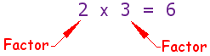

And expressions (like **x2+4x+3**) also have factors:

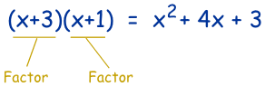

* Factoring a polynomial is the opposite process of multiplying polynomials.
* Factoring: Finding what to multiply together to get an expression.
* Recall that when we factor a number, we are looking for prime factors that multiply together to give the number; for example

6 = 2 × 3 , or 12 = 2 × 2 × 3.

Example: factor 2y+6

Both 2y and 6 have a common factor of 2:

* 2y is 2 × y
* 6 is 2 × 3

 So you can factor the whole expression into: 2y+6 = 2(y+3)

So, 2y+6 has been "factored into" 2 and y+3

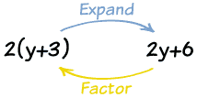

* When we factor a polynomial, we are looking for simpler polynomials that can be multiplied together to give us the polynomial that we started with.
* When we factor a polynomial, we are usually only interested in breaking it down into polynomials that have **integer** coefficients and constants.

***1. Simplest Case: Removing Common Factors: GCF***

The simplest type of factoring is when there is a factor common to every term. In that case, you can factor out that common factor. What you are doing is using the distributive law in reverse—you are sort of un-distributing the factor.

Recall that the distributive law says

*a*(*b* + *c*) = *ab* + *ac*.

Thinking about it in reverse means that if you see *ab* + *ac*, you can write it as *a*(*b* + *c*).

**Example:**  2*x*2 + 4*x*

Notice that each term has a factor of 2*x*, so we can rewrite it as:

2*x*2 + 4*x* = 2*x*(*x* + 2)

Example: factor 3y2+12y

Firstly, 3 and 12 have a common factor of 3.

So you could have: 3y2+12y = 3(y2+4y)

But we can do better!

3y2 and 12y also share the variable y.

Together that makes 3y:

* 3y2 is 3y × y
* 12y is 3y × 4

 So you can factor the whole expression into: 3y2+12y = 3y(y+4)

 Check: **3y(y+4) = 3y × y + 3y × 4 = 3y2+12y**

### *2. Factoring when a = 1 and a > 1*

**Trinomials (Quadratic)**

# Factoring Quadratics

Quadratic Equation  
[**A Quadratic Equation**](http://www.mathsisfun.com/algebra/quadratic-equation.html) **in Standard Form**  
(**a**, **b**, and **c** can have any value, except that **a** can't be 0.)

**Steps:**

1. **Is there a GCF? ALWAYS!!!**
2. **Find ac and middle term (t-chart: Factors/Middle Term)**
3. **What two numbers when multiplied together (ac) that when added or subtracted give you the middle term.**
4. **The second sign tells you if the middle term signs are the same or different.**
5. **If the second sign is positive then the signs are the same and you add to get the middle term.**
6. **If the second sign is negative then you subtract to get the middle term.**
7. **The first sign of the polynomial tells you that what the sign is if the second sign is positive (same sign: either positive or negative) and if the second sign is negative then the first sign will be the bigger number of the middle term.**
8. **Put the Parenthesis in order (_ ± _)(_ ± _)**

**Example:**

***First sign:***

Tells you what the sign is if the second sign is positive.

And if the second sign is negative then the bigger middle term number gets the sign

***Second sign:***

Positive – Same signs: ADD

Negative – Different signs: SUBTRACT & BIGGER NUMBER WINS THE SIGN.

$$x^{2}-4x+3$$

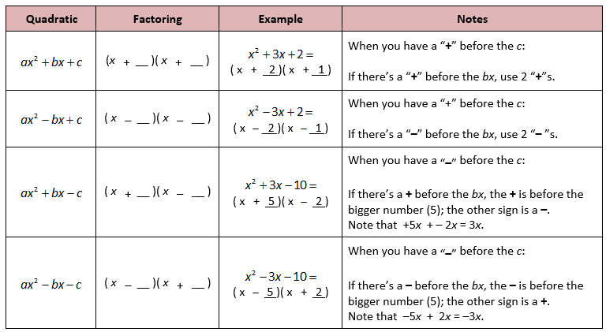

**ALWAYS CHECK YOUR ANSWER BY FOILING!**

**Example**

The factors of x2 + 3x - 4 are:

(x+4) and (x-1)

**Why?** Well, let us multiply them to see:

|  |  |
| --- | --- |
| (x+4)(x-1) | = x(x-1) + 4(x-1) |
|  | = x2 - x + 4x - 4 |
|  | = x2 + 3x - 4 yes |

Multiplying **(x+4)(x-1)** together is called [Expanding](http://www.mathsisfun.com/algebra/expanding.html).

In fact, Expanding and Factoring are opposites:

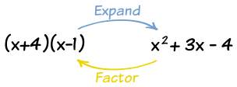

***Ways to Factor:***

1. ***Guess & Check***
2. ***Grouping***
3. ***Box Method***
4. ***X-chart***
5. ***DOTS: Difference of two Squares***
6. **GROUPING**

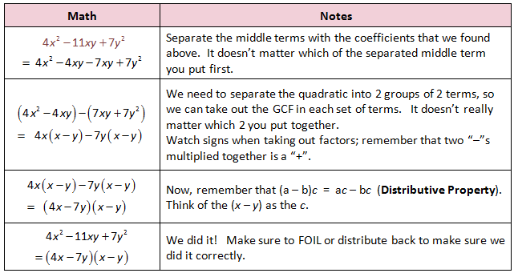

1. BOX METHOD

|  |  |  |
| --- | --- | --- |
| GCF |  |  |
|  | 1ST TERM | FACTOR |
|  | FACTOR | 3RD TERM |

EXAMPLE: $10x^{2}-11X-6$

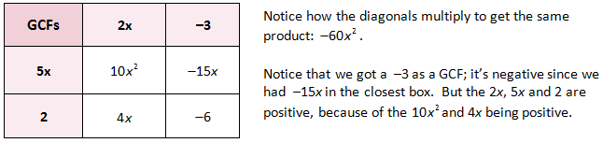

SOLUTION: $(5X+2)(2X-3)$

1. **X-CHART**

**ac Product**

‘X’ CHART INTO FRACTIONS OF 

**Factor**

**Factor**

**b Sum**

**b: Sum**

EXAMPLE:

* 1. Find ac
  2. Find the two numbers that multiply to ac and add to get b
  3. Take a and divid it by the two factors (simplify the fraction if possible).
  4. The top number (a) is your coefficient of x (ax)
  5. Put it in parentheses: ( )( ):

Example: $3x^{2}-8x+4$

$\frac{3}{6},\frac{3}{2}=\frac{1}{2},\frac{3}{2}$ $(3x-2)(x+2)$

$$factor: 2$$

$$factor: 6$$

ac: $3×4=12$

$$b: 2+6=8$$

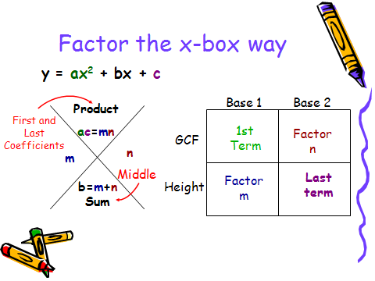

***3. Difference of Two Squares***

If you see something of the form *a*2  *b*2, you should remember the formula

http://www.jamesbrennan.org/algebra/polynomials/factoring_files/image002.gif

**Example: Factor 4x2 - 9**

Hmmm... I can't see any common factors.

But if you know your [Special Binomial Products](http://www.mathsisfun.com/algebra/special-binomial-products.html) you might see it as the **"difference of squares"**:

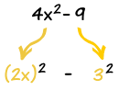

Because **4x2** is **(2x)2**, and **9** is **(3)2**,

so we have: 4x2 - 9 = (2x)2 - (3)2

And that can be produced by the difference of squares formula: (a+b)(a-b) = a2 - b2

Where **a** is 2x, and **b** is 3.

So let us try doing that: (2x+3)(2x-3) = (2x)2 - (3)2 = 4x2 - 9

Yes!

 So the factors of **4x2 - 9** are **(2x+3)** and **(2x-3)**: Answer: 4x2 - 9 = (2x+3)(2x-3)

**Example:**  *x*2 – 4 = (*x* – 2)(*x* + 2)

* This only holds for a **difference** of two squares. There is no way to factor a **sum** of two squares such as *a*2 + *b*2 into factors with real numbers.

### Example: w4 - 16

An exponent of 4? Maybe we could try an exponent of 2: w4 - 16 = (w2)2 - 42

Yes, it is the difference of squares w4 - 16 = (w2 + 4)(w2 - 4)

And "(w2 - 4)" is another difference of squares w4 - 16 = (w2 + 4)(w+ 2)(w- 2)

### Example: 3u4 - 24uv3

Remove common factor "3u": 3u4 - 24uv3 = 3u(u3 - 8v3)

Then a difference of cubes: 3u4 - 24uv3 = 3u(u3 - (2v)3)

= 3u(u-2v)(u2+2uv+4v2)

### Example: z3 - z2 - 9z + 9

Try factoring the first two and second two separately: z2(z-1) - 9(z-1)

Wow, (z-1) is on both, so let us use that: (z2-9)(z-1)

And z2-9 is a difference of squares (z-3)(z+3)(z-1)